Venue Hire

Venue Capacity
Function Room | The Dray | Dray Marquee | Whites | Shires | Roundel
U-Shape | 70 | 70 | 30 | 20 | 15
Boardroom | 80 | 90 | 40 | 30 | 18
Theatre | 400 | 340 | 150 | 30 | 25
Classroom | 150 | 120 | 120 | 20 | 15
Cabaret | 200 | 250 | 120 | n/a | 10
Dinner Dance | 150 | 200 | 90 | 40 | n/a
Reception | 300 | 450 | 200 | 200 | n/a

Room Rates
Half Day = 8am - 12pm/1pm - 5pm - Mid week only Full Day = 8am - 5pm - Mid week only

Shires
Half Day £325 + VAT
Full Day £450 + VAT
Whites
Half Day £325 + VAT
Full Day £450 + VAT
Roundels
Half day £100 + VAT
Full Day £150 + VAT
Dray
Half Day £750 + VAT
Full Day £1000 + VAT

Evening and Weekend Hire
Includes use of the Bar, and Bar Staff in either of our Whites/Shires or Dray Venue

Exclusive Weekend Hire 9am-12am
£1750+VAT
Exclusive Evening Hire 6pm-12am
£950+VAT

Refreshment Options

Unlimited Tea & Coffee
£2.50+VAT pp
Fresh Ground Coffee
£3.00+VAT pp
Bacon, Sausage or Egg Baps
£2.90+VAT pp
Breakfast Pastries
£1.50+VAT pp
Tray of Biscuits (Serves 10)
£5.50+VAT each
Jug of Apple/Orange Juice
£4.50+VAT each
Bottled Water
£1.50+VAT pp
Bottle of Cordial
£2.50+VAT each
Fresh Fruit Basket (Serves 10)
£21.00+VAT each
Homemade Shortbread & Cookies
£2.00+VAT pp
Homemade Brownies & Flapjacks
£3.50+VAT pp
Homemade Cakes & Scones
£4.50+VAT pp

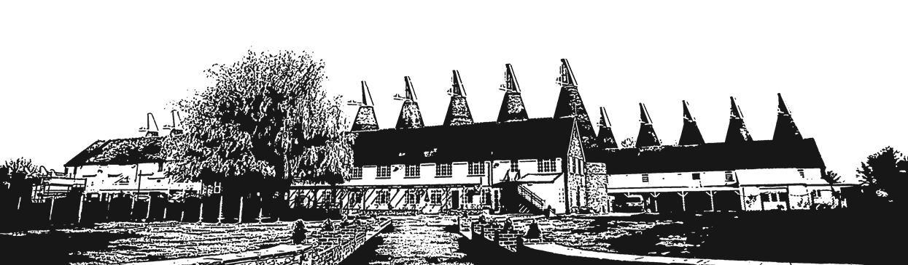
Food Options
Price includes all table linin and napkins required

Finger Buffet
£10.25+VAT pp
BBQ Buffet
(Min 30 Guests)
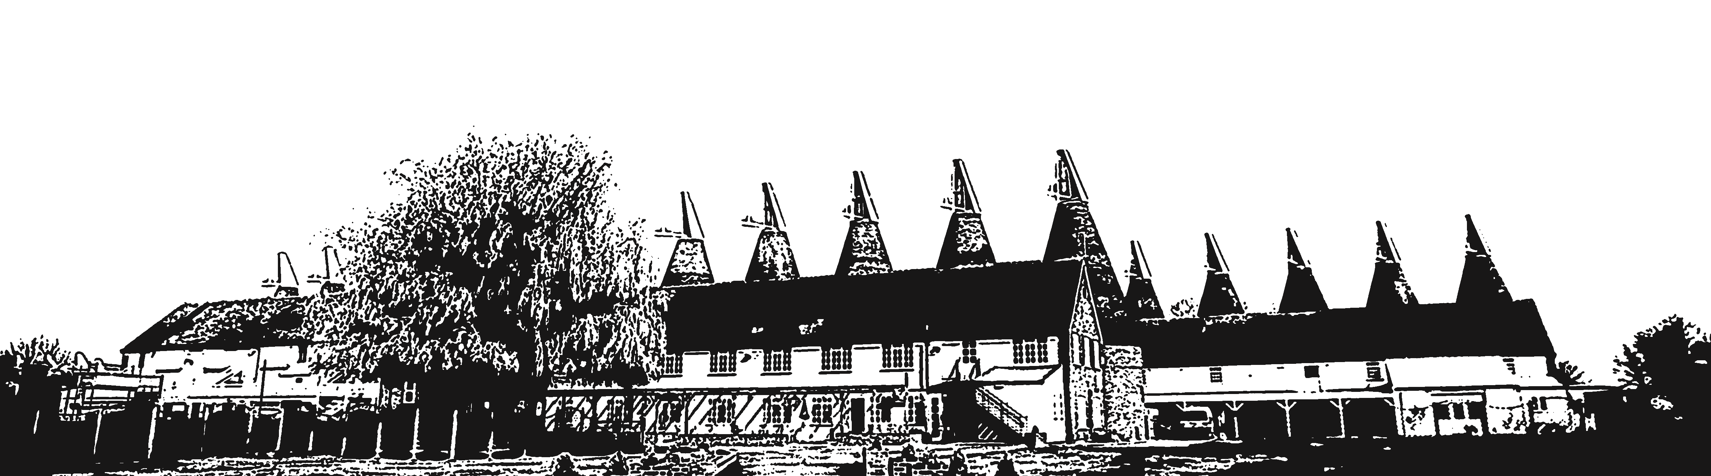
£16.60+VAT pp

Hot Fork Buffet
£15.25+VAT pp
Hog Roast Buffet
(Min 80 Guests)
£14.15+VAT pp

Sandwich/Wraps & Tortilla Crisps
£4.95+VAT pp
3 Course Sit Down Dinner
(Min 30 Guests)
£31.95+VAT pp

*Add a Desert Table for just £3+VAT per person*

